

THE COPPERBELT UNIVERSITY  
SCHOOL OF INFORMATION COMMUNICATION TECHNOLOGY

Smart Bin: Reward-Based Waste Sorting  
System

Design Specification  
  
**Done By**

Name: Bulaya Mwanaute

SIN: 20150307

Programme: Computer Engineering

**Supervised By**

Professor J. Mbale

# Table of Contents

Abstract 1

Declaration 2

Dedications 3

Acknowledgements 4

Table of Contents 5

List of Figures 6

List of Tables 7

Chapter 1: Introduction 1

1.1. Introduction 1

1.2. Background of Study 1

1.3. Problem Statement 1

1.4. Objectives 2

1.5. Hypothesis and Assumptions 2

1.6. Purpose, Scope and Applicability 2

1.7 Organisation of the Project 3

Chapter 2: Literature Review 4

2.1. Introduction 4

2.2. Related Work 4

2.2.1 Waste Sorting at the Disposal Stage 4

Current Practices and Technologies 5

Benefits of Sorting at the Disposal Stage 6

Challenges and Why It's Not Yet Widespread 6

Gaining Traction: The Path Forward 7

2.2.2 AI-Based Waste Classification 8

AI Methodologies in Waste Classification 8

Applications and Benefits 9

Challenges and Limitations 9

2.2.3. Reward-Driven Recycling 10

Types of Rewards and Incentives 10

Effectiveness and Benefits 10

Challenges and Limitations 11

2.2.4. Disposal Behaviour and User Incentives 12

Disposal Behavior 12

User Incentives 12

Smart Bin Placement 13

2.3. Previous Systems 13

2.4. References 13

Chapter 3: Research Methodology 18

3.1. Introduction 18

3.2. Methodology 18

Chosen Methodology: Agile with Hardware-Software Co-Design 18

Phases of Implementation: 18

System Development Approach 19

Tools and Technologies 19

3.3. Information Gathering And Analysis 19

3.4. Requirements Specification 19

3.4.1 User Requirements 20

3.4.2 System Requirements 20

Functional Requirements 20

Non-Functional Requirements 20

3.5. System Analysis 20

3.6. Conclusion 21

Chapter 4: System Design 22

4.1. Introduction 22

4.2. System Analysis 22

4.3. Context Model 22

4.4. Design Methods 22

4.4.1. Architectural Design 23

4.4.2. Detailed Design 25

4.4.3. Physical Design 25

4.5. Conclusion 25

# Chapter 4: System Design

## 4.1. Introduction

This chapter presents the design process and engineering decisions behind the development of the Smart Bin: AI-Driven Waste Sorting System. It outlines the system architecture, key hardware and software modules, and how the various components interact to achieve autonomous waste classification, sorting, and user engagement through a reward mechanism.

Throughout the development of this project, a number of design decisions were made, each informed by technical feasibility, resource availability, and real-world usage considerations. For example, the choice to classify only plastic, paper, and metal waste was guided by early observations of common disposal habits in public environments, as well as survey feedback from potential users. Similarly, the decision to implement on-device waste classification using a lightweight model such as YOLO was influenced by the system’s embedded nature and power constraints.

Trade-offs had to be made between accuracy and speed, hardware complexity and cost, and user experience and system autonomy. In several cases, iterative testing and prototyping guided the refinement of the design.

The sections that follow describe:

* The overall system architecture, including how hardware and software components are integrated.
* The breakdown of individual modules, such as the AI-based classification unit, actuation logic, and reward system.
* The design of the interfaces between hardware and software components.
* An overview of algorithms used for classification and control.
* Maintenance recommendations for long-term use and deployment in public spaces.

Additionally, this chapter provides a rationale for each major design decision, along with reflections on challenges encountered and how they were addressed. Once the survey period concludes, its findings will be incorporated to further validate or refine the system design and its targeted use environments.

## 4.2. System Analysis

The Smart Bin system was conceptualized to address a growing need for more intelligent and autonomous waste disposal solutions in public and semi-public spaces. Traditional bins often lead to mixed waste streams, low recycling efficiency, and limited user engagement in proper waste disposal practices. The core problem identified is the lack of an accessible, automated solution that can perform real-time waste classification and sorting, while simultaneously incentivizing users to participate in correct disposal behavior.

Based on the requirements specification and the information gathered through observation, literature review, and ongoing surveys, the system must fulfill the following high-level objectives:

* Automatically identify and classify commonly discarded waste items into plastic, aluminum (metal), or paper categories.
* Sort waste into the correct physical compartments without requiring manual intervention.
* Detect when a compartment is full and lock the system to prevent overfilling.
* Provide user feedback (via LED/buzzer) to indicate bin status.
* Optionally dispense a reward token to incentivize correct disposal.
* Operate autonomously and reliably on portable power, suitable for public environments.

These objectives must be achieved while ensuring:

* Low latency during classification and sorting (to prevent user frustration)
* High accuracy in detection (to ensure correct sorting and fair rewards)
* Physical safety and robustness for public deployment

The system also needs to accommodate future improvements, such as:

* Real-time usage logging and data analytics
* Wireless connectivity for remote monitoring
* Support for dynamic model updates (e.g. via SD card or OTA)

Thus, this analysis phase identifies what the system should do to solve the problem it was designed for — offering a blueprint for the design phase to determine how these needs will be technically fulfilled.

## 4.3. Context Model

The context model defines the boundaries between the Smart Bin system and its external environment. It identifies all the external entities that interact with the system and the nature of data or control flows exchanged with them.

At the center of the model is the Smart Bin System, which is influenced by multiple external entities. These include the User, who disposes of waste and receives feedback or rewards; the Maintenance Staff, who empties compartments and resets the bin; the Power Source, which provides energy for all operations; and the physical environment, particularly lighting conditions that may affect the performance of the vision system. Additionally, survey participants and datasets form part of the contextual environment during development and training of the AI model.

These interactions are visually represented in the system’s context diagram, which forms the basis for identifying system boundaries, responsibilities, and external interfaces during design.

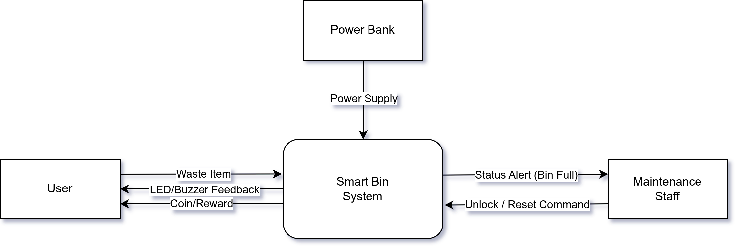

Figure 8: Smart Bin context diagram

## 4.4. Design Methods

### 4.4.1. Architectural Design

The architectural design of the Smart Bin System outlines the high-level structure of both the hardware and software subsystems, and how they interact to meet the functional and non-functional requirements. The architecture is designed for modularity, allowing each component to handle a specific responsibility within the overall system workflow as illustrated in the figure below.

#### Hardware Architecture

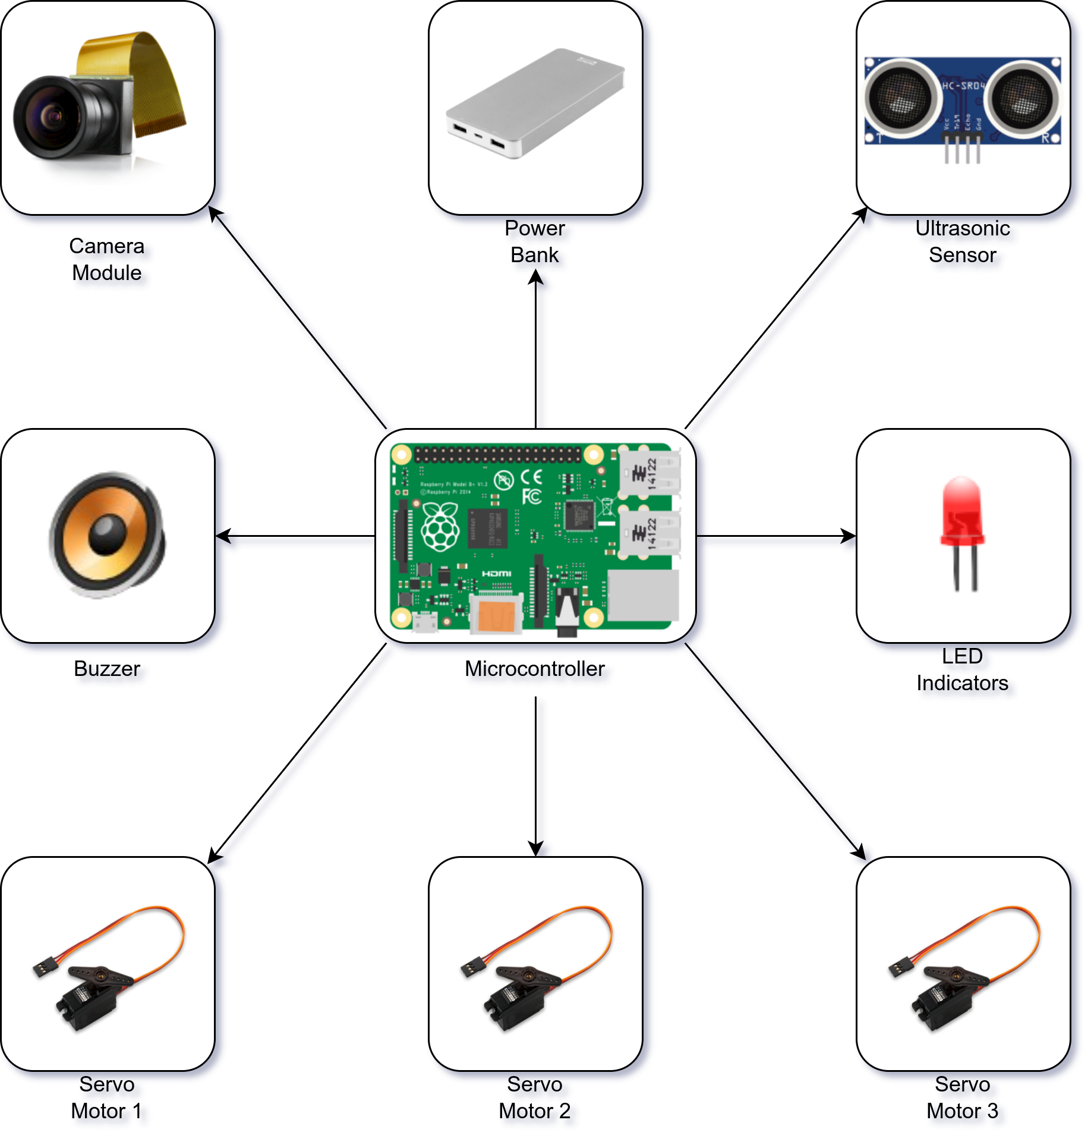

Figure 9: Smart Bin Hardware Architectural Design Diagram

* Power Bank: Portable power source to supply to all hardware components
* Microcontroller: Core processing unit for input/output control and integration logic
* Camera Module: Captures images of incoming waste for classification
* Servo Motor 1: Rotates platform to align the correct compartment beneath the drop point
* Servo Motor 2: Controls the lid opening/closing and drop release mechanism
* Servo Motor 3: Activates coin dispenser for reward when recyclable material is detected
* LED Indicator: Provides visual feedback (e.g., bin full, item accepted, error state)
* Speaker/Buzzer: Emits sound for alerts (e.g., successful drop, bin full, invalid item)

#### Software Architecture

The software component is structured into modules:

* **Image Capture Module** – interfaces with the camera to obtain images
* **AI Classification Module** – runs a YOLO-based model to classify the object into plastic, paper, or metal
* **Control Logic Module** – interprets classification results and manages mechanical operations (rotation, dropping, locking)
* **Feedback Module** – activates LEDs and buzzer signals
* **Fullness Monitoring Module** – reads from the ultrasonic sensor and determines whether to lock input
* **Reward Module** – controls coin dispensing logic

This modular architecture ensures clear separation of concerns and supports future scalability, such as adding data logging, wireless connectivity, or remote monitoring features.

#### System Integration

The microcontroller acts as the central processing and coordination unit, interfacing with sensors and actuators in real time. The entire system operates offline and autonomously, powered by a portable power source. The architecture has been designed to meet requirements for speed, accuracy, portability, and safety in public environments.

### 4.4.2. Detailed Design

The detailed design phase breaks down the Smart Bin System into individual functional modules and describes the behavior, logic, and interfaces of each module. The system follows a modular approach to ensure separation of concerns, ease of testing, and scalability. Each module is responsible for a specific function within the waste classification, sorting, and reward workflow. The design methodology used is Structured Analysis and Design (SAD), and system logic is further expressed through a Data Flow Diagram and pseudocode.

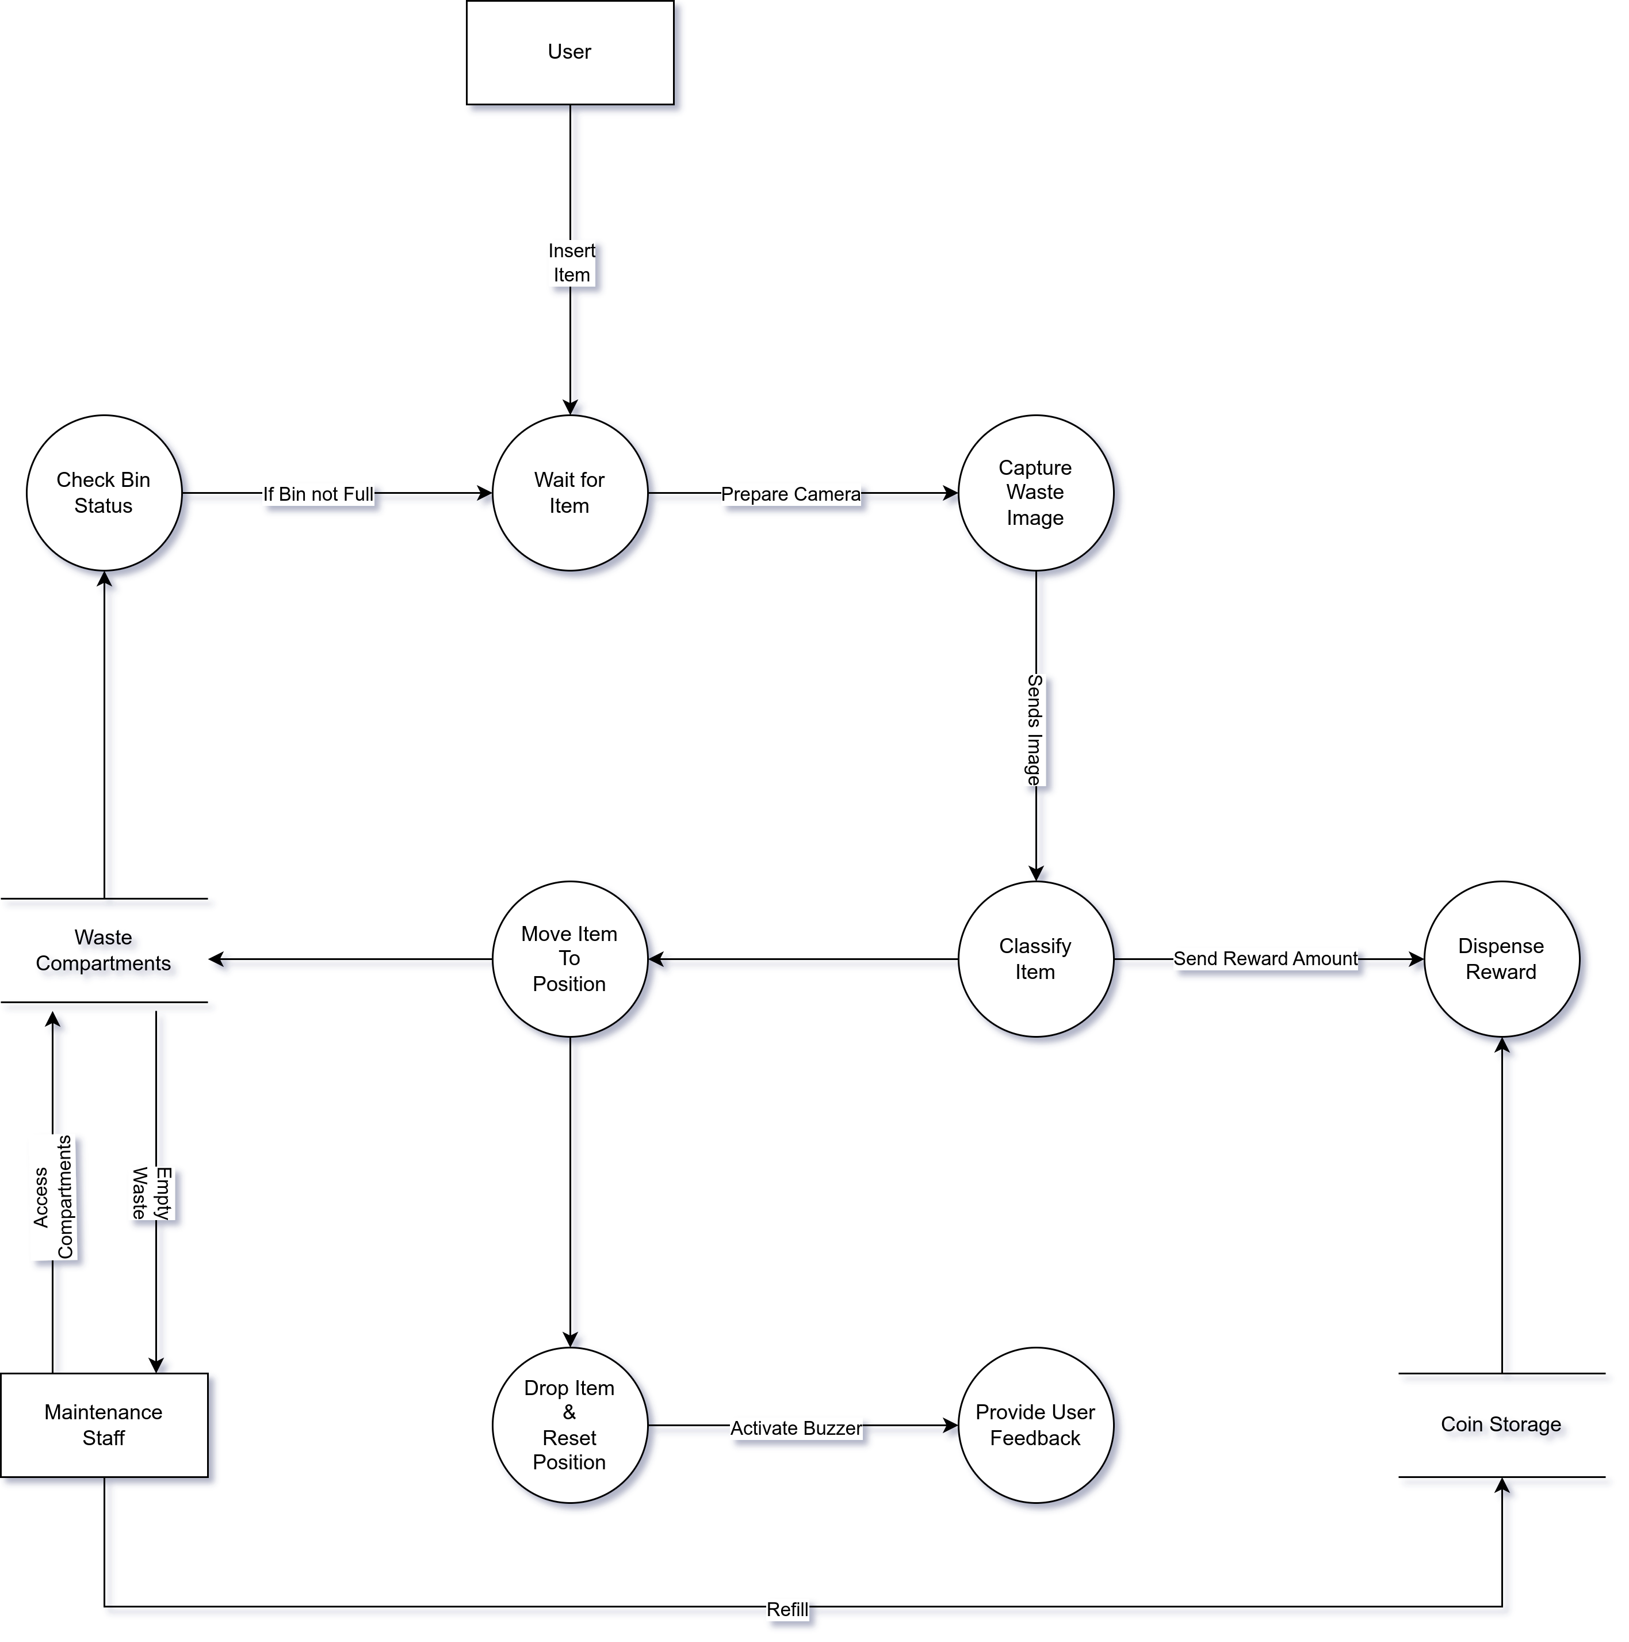

Figure 10: Smart Bin Data Flow Diagram

1. **Image Capture Module**

Purpose: This module captures an image of the waste item once inserted by the user.

* Input: Trigger signal when bin lid is closed
* Output: Still image (frame) sent to classification module
* Interface: Camera module (e.g., ESP32-CAM or USB camera)
* Process:
* Wait for lid to close
* Capture high-resolution image
* Send image to AI classification module

1. **AI Classification Module**

Purpose: Performs object detection using a lightweight YOLOv5 model to identify the material type.

* Input: Image from camera
* Output: Waste class label (plastic, paper, metal) or unknown
* Process:
  + Preprocess the input image
  + Run inference using pre-trained YOLO model
  + Return the class with highest confidence
* Design Choice: YOLO was chosen for its speed, accuracy, and ability to run on low-resource devices with quantized weights.

Pseudocode (simplified):

|  |
| --- |
| def classify(image):  result = yolo_model.predict(image)  if result.confidence > threshold:  return result.label  return "misc" |

1. **Linear Motion Control Module**

Purpose: Moves the waste container horizontally (along a track or guide rail) to position it above the correct waste compartment (plastic, paper, or metal).

* Input: Waste class label from AI module
* Output: Positioning signal to a linear actuator or belt-driven motor
* Interface: Stepper motor or DC motor with position feedback (e.g., via limit switches or encoders)
* Process:
  + Map each class label to a fixed horizontal position:
    - Plastic → position A
    - Paper → position B
    - Metal → position C
    - Misc → position D
  + Activate the motor to translate the container horizontally until the correct position is reached
  + Optionally, use limit switches or sensor feedback to detect arrival at each position
  + Signal the dropping mechanism module to proceed with releasing the item

1. **Dropping Mechanism Module**

Purpose: Opens a trapdoor or gate to drop the waste item into the aligned compartment.

* Input: Confirmation that rotation is complete
* Output: Drop signal to servo
* Interface: Servo motor attached to gate
* Process:
  + Activate gate servo
  + Wait fixed time (e.g. 2 seconds)
  + Close gate

1. **Bin Status Module**

Purpose: Checks whether the compartment for the predicted class is full, using an ultrasonic sensor.

* Input: Class label
* Output: Boolean flag (full/not full)
* Interface: Ultrasonic sensor mounted above each compartment
* Process:
  + Trigger and read distance from sensor
  + Compare with pre-set threshold
  + If full, lock bin and activate error feedback

1. **Reward Module**

Purpose: Dispenses a coin/token if the item is correctly classified and dropped.

Condition: Only dispense reward for classified recyclable items (plastic, metal, or paper).

If the classification result is misc, the drop process still occurs, but no reward is dispensed.

* Input: Success flag from drop mechanism
* Output: Servo actuation to release a coin
* Interface: Servo motor on coin dispenser
* Process:
  + Trigger servo for brief release motion
  + Wait fixed duration
  + Reset dispenser

1. **User Feedback Module**

Purpose: Provides real-time feedback using LEDs and buzzer tones to guide the user.

* Input: System state (e.g., idle, processing, error, bin full)
* Output: Colored LED signal and/or buzzer tone
* Examples:
  + Green LED → Ready
  + Yellow LED → Processing
  + Red LED or buzzer → Bin full / item unrecognized
  + Interface: GPIO lines to RGB LED and piezo buzzer

1. **System Coordination and Control Logic**

Purpose: Ensures the correct sequence of actions from start to finish.

Sequence:

1. Wait for item insertion (lid closes)
2. Capture image
3. Run classification
4. Check compartment status
5. If valid and not full:
   * Translate container to correct position
   * Drop item
   * Dispense reward
6. If classified as misc:
   * Move to miscellaneous compartment
   * Drop item
   * No reward dispensed
7. If classified item’s bin is full:
   * Lock bin and trigger full-bin feedback

### 4.4.3. Physical Design

The physical design of the Smart Bin system outlines how users interact with the device, how internal components are arranged, and how data and items move throughout the system. It focuses on input and output design, mechanical layout, and real-world usability in public or commercial settings.

#### **a) User Interaction**

Users interact with the system by placing a waste item into the input container located at the top of the bin. Once the item is inserted and the lid is closed, the bin temporarily locks to prevent interference during processing. After classification and sorting are complete, the bin automatically reopens, and — if applicable — dispenses a coin as a reward for proper disposal. The system uses LED indicators and/or a buzzer to inform the user of current status (e.g., idle, processing, full).

#### **b) Mechanical Layout**

Internally, the bin is divided into four compartments: plastic, paper, metal, and miscellaneous. The top container holding the waste item is mounted on a linearly translating platform (e.g., a belt or guide rail) controlled by a motor. After classification, the platform slides horizontally to align the container with the correct compartment. A servo-driven trapdoor beneath the container then opens, allowing the item to drop.

The compartments may each have a dedicated ultrasonic sensor to detect fullness. When a compartment is full, the system prevents further drops into that section and alerts maintenance staff.

#### **c) Data and Control Flow**

The camera module captures the image, which is classified by an onboard AI model. The result determines which compartment to move to. After verifying that the target compartment is not full, the bin executes the drop and optionally dispenses a coin. If the item is unrecognized, it is directed to the miscellaneous compartment and no reward is given.

#### **d) Output and Feedback**

Visual and auditory feedback is provided to users at each stage of the interaction:

* Green LED: Idle/Ready
* Yellow LED: Processing
* Red LED or buzzer: Full bin / error
* Coin slot and dispenser: Rewards for valid items

## 4.4. Conclusion

This chapter has detailed the overall design and architectural framework of the AI-Driven Smart Bin system. It began with the selection of a modular, structured approach for both hardware and software design, guided by the Structured Analysis and Design (SAD) methodology.

The design was broken down into architectural, detailed, and physical layers. At the architectural level, the high-level structure and hardware-software interaction were defined. The detailed design outlined the internal modules — such as image capture, classification, sorting logic, reward dispensing, and user feedback — while the physical design emphasized real-world interaction, internal layout, and 3D structural representation.

Furthermore, a comprehensive Data Flow Diagram (DFD) was developed to visually communicate the movement of data throughout the system, highlighting the interactions between the user, maintenance staff, control logic, and data stores. This structured breakdown provides a foundation for the implementation phase, ensuring all critical functions are addressed and logically connected.

The design also reflects the project's scalability, safety, and sustainability goals — providing a blueprint not only for prototyping but also for future iterations or enhancements.